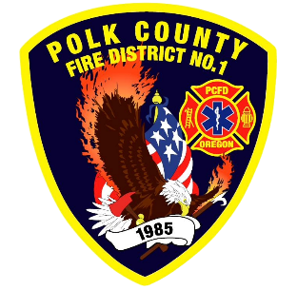
Fire Prevention Report
Division Chief Fire Marshal Troy Crafton
May 2026

April Events
Plan Review, Inspections, Training, Incident Response
- Station Tour
- License Inspection
- Riddle Road Apartments Final 1 Building
- Prism Final Inspection
- Temp Occupancy Ross Theater
- 6 - Food Truck Inspections
- 1 - Complaint Inspections
- 1 - Driveway inspections
- 11 - Business Inspection
- 16 - Plan Review Projects
- 1 - Smoke Alarm Installs
- Flow MSP set up and Pre-Plans
- Risk Reduction Grant for District Addressing / Preplanning / Wildfire Mitigation
- 8 Hours Fire Marshal Service IGA Dallas Fire Department
- 0 Hours Fire Marshal Service IGA Polk County Building Department
- 4 Incident With 4.5 Hours of Response
Upcoming Events
- Touch-A-Truck
- Fire Safety at TMS
- Forensic Science at TMS
- Deaf Blind Q and A
- IAAI Meeting
- MBA Meeting
- MICC Meeting
- Safety Committee Meeting
- Officer Meeting
- Monmouth City Project Meeting
- Independence City Project Meeting
- Monmouth Building Meeting Every Thursday
- Dallas DRT Meeting Every Thursday
- MPFIT Meeting
- OLST Meeting
- Youth with Fire Workshop
Activities
- Willamette Valley Wildfire Coalition
- Youth with Fire Workshop
- Youth Fire intervention
- Pre-Application Meeting - 635 Walnut
- Education Webinar Series: Improving Relationships
- Pre-26-02 16th St Subdivision
- Pre-Application Meeting - 4785 Independence Hwy
- Pre-Application Meeting - 635 Walnut
- Pre-Application - 1201 Stryker Road
- Pre-Application - Polk and Ash Street
- Safety Committee Meeting
- Officer Meeting
- Monmouth City Project Meeting
- Independence City Project Meeting
- Monmouth Building Meeting Every Thursday
- Dallas DRT Meeting Every Thursday
- MPFIT Meeting
- Youth with Fire Workshop
- Fire Official Quarterly Meeting

