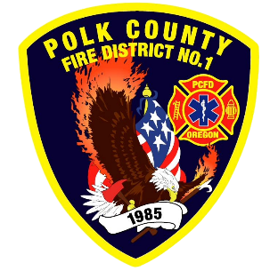
Fire Prevention Report
Division Chief Fire Marshal Troy Crafton
December 2025

November Events
Plan Review, Inspections, Training, Incident Response
- CHS Transition Fire Extinguisher Training
- MES Station Tour
- 8 Mobile Food Truck Inspections
- 1253 6th St License Inspection
- Cabinet Works Group Inspection
- Central School Inspections
- 2 Driveway inspections
- 10 Business Inspection
- 12 Plan Review Projects
- 2 Smoke Alarm Installs
- Flow MSP set up and Pre-Plans
- Risk Reduction Grant for District Addressing / Preplanning
- 9 Hours Fire Marshal Service IGA Dallas Fire Department
- 0 Hours Fire Marshal Service IGA Polk County Building Department
- 4 Incident With 3.25 Hours Of Response
Upcoming Events
- Pre-Application Independence
- WOU Tree Lighting
- Santa Train
- Safety Committee Meeting
- Officer Meeting
- Monmouth City Project Meeting
- Independence City Project Meeting
- Monmouth Building Meeting Every Thursday
- Dallas DRT Meeting Every Thursday
Activities
- Safety Committee Meeting
- Officer Meeting
- IAAI Meeting
- OLST Meeting
- Monmouth City Project Meeting
- Independence City Project Meeting
- Monmouth Building Meeting Every Thursday
- Dallas DRT Meeting Every Thursday

