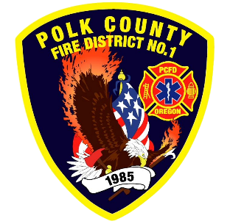
Training and Operations Report
Deputy Chief Training/Operations Neal Olson
May 2026
March Events
Training, Public Education Events, Special Events
- 4/1 Officer and P1FFA Meeting, Academy Hose Skills
- 4/3 Olson teaching CPR Science at DPSST
- 4/7 Strategic Plan and Safety Committee Meeting
- 4/8 Captain Assessment Center
- 4/8 Drill - Extended Attack Lines, Academy Hose
- 4/9 Board of Directors Meeting
- 4/15 Drill - Utilities, Water Supply, Academy Loss Control
- 4/22 Olson on Wildland Certification Task Force at DPSST
- 4/22 Drill - 3rd Floor Standpipes, Academy Building Construction
- 4/23 Keizer Fire Accreditation Review
- 4/28 Polk County Mobilization Resource Meeting

Upcoming Events
- 5/2 OSFM Engine Boss Forum
- 5/6 Officer and P1FFA Meeting, Academy: Fire Service Tools
- 5/9 Recruit Academy: Forcible Entry and Vehicle Fires
- 5/11 Fire Services Meeting at WVCC
- 5/13 Wildland Refresher Training and Engineer Academy
- 5/18 Fire District Budget Meeting
- 5/20 Capitol Region Operations Meeting at Salem Fire
- 5/20 Wildland Refresher Training and Engineer Academy
- 5/25 Memorial Day Holiday, Office closed
- 5/27 Wildland Refresher Training and Engineer Academy
- 5/30 Recruit Academy: Tactical Ventilation

Informational Items
- 322 Incidents last month.
- 1,121 Hours of Training and Continuing Education last month.

- 22 Certification(s) received last month
  - Caleb Taylor: Live Fire Instructor
  - Brenden Shellito: Live Fire Instructor In-Charge, Fire Inspector I and II
  - Max Patel: Driver and WFAO
  - Elijah King: Driver and WFAO
  - KB: Driver, WFAO and FFT2
  - Troy Crafton: FFT2, FLSE 2
  - Xander Bailey: FFI, HMA, HMO
  - Dakota Allen: FFI, HMA, HMO
  - Teagen Allen: FFI, HMA, HMOAlex Schilz - Mobile Water Supply Apparatus Operator

Training Calendar
