

October Report for the month of September 2025

Deputy Chief – Neal Olson

**This Month’s Events** (i.e. Training, Public Education Events, Special Events)

* 9/1 Labor Day Holiday - Office Closed
* 9/3 Officer and P1FFA Meetings
* 9/5 CHS Football Standby
* 9/6 WOU Football Standby
* 9/6 EE Wilson Live Fire Operations with Adair Fire and ODF
* 9/10 Drill - START Triage
* 9/11 Board of Directors Meeting
* 9/15 Albany Fire will be training in our drill tower Monday-Thursday
* 9/17 Drill - MCI Resources
* 9/20 WOU Football Standby
* 9/23 PALS Training
* 9/24 Drill - MCI Drill: Multi-Company Evolution
* 9/26 CHS Football Standby

**Upcoming Events** (i.e. Training, Public Education Events, Special Events)

* 10/1 Blood Drive at Sta. 90
* 10/1 Olson teaching EMD at DPSST
* 10/1 Officer Meeting and P1FFA Meetings
* 10/4 EMS Standby at WOU Football
* 10/8 Drill - Vehicle Stabilization
* 10/9 Board of Directors Meeting
* 10/10 EMS Standby at CHS Football
* 10/11 Extrication Day
* 10/14 Holiday - Be Bald and Be Free Day
* 10/15 Drill - Extrication Tools
* 10/18 EMS Standby at WOU Football
* 10/22 Drill - Vehicle Extrication
* 10/23 ACLS Class at Sta. 90
* 10/26 National First Responders Day
* 10/28 OSHA Inspection
* 10/29 Drill - Extrication Multi-Company Drill
* 10/31 EMS Standby at CHS Football
* 11/1 EMS Standby at WOU Football

**Informational Items –**

* 321 Incidents last month.
* 530 Hours of Training and Continuing Education last month.
* 4 Certification(s) received last month
  + Harmony Alvarez - Firefighter Type 1
  + Stephen Hoem - Instructor 2
  + Doug Stewart - Wildland Fire Apparatus Operator and Mobile Water Supply Apparatus Operator

Training Calendar

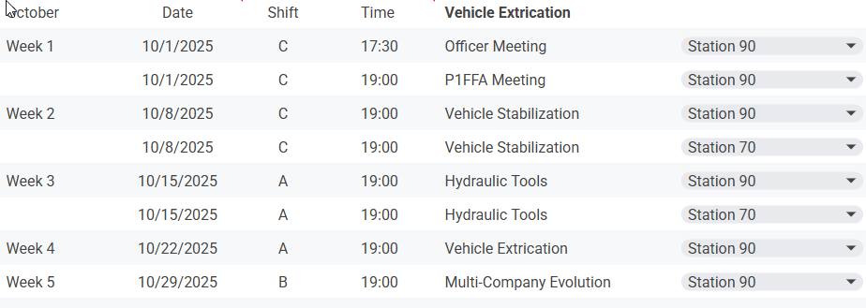

*Respectfully Submitted*

***Neal Olson***