

July 2025 Report for the month of June 2025

Deputy Chief – Neal Olson

**This Month’s Events** (i.e. Training, Public Education Events, Special Events)

* 6/4 Officer meeting and P1FFA meeting
* 6/7 Recruit Academy Extrication Class
* 6/7 Metro Area Wildfire School (MAWS)
* 6/7 Thoughts and Gifts Project Gift Drive
* 6/11 Drill - Confined Space Awareness and Gas Monitors
* 6/12 Board of Directors Meeting, Independence Days Commission Meeting
* 6/13 Drakes Crossing Accreditation Review
* 6/14 WOU Commencement Ceremony
* 6/18 Peer Support Symposium at DPSST
* 6/18 Drill - Structural Search Tactics
* 6/19 Juneteenth Holiday
* 6/19-22 OVFA Conference
* 6/21 Recruit Academy Skills review
* 6/23 EMS Drill
* 6/25 Drill - Recruit Task Performance Evaluations and Station Cleanup for July 4th.
* 6/28 Mud Factor Run

**Upcoming Events** (i.e. Training, Public Education Events, Special Events)

* 7/2 Recruit Graduation, Swearing in of recently promoted personnel
* 7/3 Hometown Fireworks
* 7/4 Pancake Feed and July 4th Festivities
* 7/9 Drill - Firefighter Survival and Breathing Techniques, Engineer Academy
* 7/16 GRABLIVES Firefighter Survival, Engineer Academy
* 7/21 EMS Drill
* 7/23 Drill – Forcible Entry, Engineer Academy (DPSST will be providing their Forcible Entry Prop for our personnel to utilize from July 19 through Aug 4, 2025)
* 7/30 Drill - Structural Search, Thermal Imaging Cameras and Engineer Academy

**Informational Items –**

* **346** Incidents last month.
* **522** Hours of Training and Continuing Education last month.
* **11** Certification(s) received last month
  + Camila Alarcon - Firefighter I
  + Brady Andersen - Wildland Firefighter Type 1
  + Seamus Connerly - Wildland Firefighter Type 2, HazMat Awareness and Operations
  + Avery Gaul - HazMat Awareness and Operations
  + Naomi Kersey-Bronec - Firefighter I
  + Scott Lamoreaux - Firefighter I
  + Leo Mellein - Wildland Firefighter Type 2
  + Max Patel - Firefighter I

Training Calendar

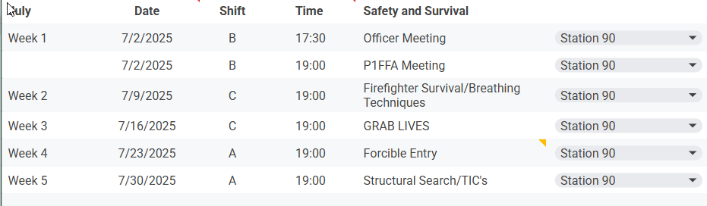

*Respectfully Submitted*

***Neal Olson***