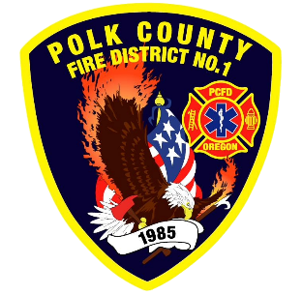
EMS and Logistic Report
Division Chief of EMS/Logistics Frank Ehrmantraut
January 2026

December Highlights
- A group of OHSU RN students that are based out of Western Oregon University attended a two-day class at Station 90 to obtain their ACLS Certification. The District has had an ongoing partnership with the nursing program and their students that has been mutually beneficial
- The District hosted the American Red Cross who performed a blood drive. Blood drives held at the District are some of the most successful drives for the Red Cross in the region.
- The District met with leadership at DPSST to discuss the possibility of The Shops at PCFD providing for some of their maintenance needs.

Apparatus Updates
- M477 - Brakes inspected and replaced, rear door seals replaced, LOF
- T465 – Tires, interior cab light and rear input plumbing replaced
- L456 - Milwaukee Chargers added to compartment for tools and lighting
- S406 - Sold ($8,000) after response equipment and stickers removed.
- E473 - Compartment door sensor repaired and coolant topped off.
- S484 - New C90 rig placed into service after upfitting at Wireworks
- E461 - Working on air leaks and compressor
- B459 - New tires and in process of adding a leveling kit, scene and ground lighting, and other small adjustments to make it more efficient
- R485 - Currently at True North for warranty repairs.

