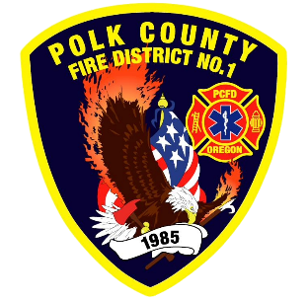
Fire Prevention Report
Division Chief Fire Marshal Troy Crafton
February 2026

January Events
Plan Review, Inspections, Training, Incident Response
- TMS Forensics Science Class
- MPFIT Burn to Learn
- MPFIT Fire Investigation Class
- PUB ED Deaf Blind Q&A
- JB Wood products Inspection
- Hoxton Apartments Inspection
- 5 Business Complaint Inspections
- 1 Driveway inspections
- 10 Business Inspection
- 14 Plan Review Projects
- 2 Smoke Alarm Installs
- Flow MSP set up and Pre-Plans
- Risk Reduction Grant for District Addressing / Preplanning
- 7 Hours Fire Marshal Service IGA Dallas Fire Department
- 0 Hours Fire Marshal Service IGA Polk County Building Department
- 2 Incident With 1.5 Hours of Response
Upcoming Events
- Safety Committee Meeting
- Officer Meeting
- Monmouth City Project Meeting
- Independence City Project Meeting
- Monmouth Building Meeting Every Thursday
- Dallas DRT Meeting Every Thursday
- MPFIT Meeting
- OLST Meeting
- Youth with Fire Workshop
Activities
- Pre-App 203 Monmouth St
- Youth with Fire Workshop
- Safety Committee Meeting
- Officer Meeting
- MPFIT Meeting
- Monmouth City Project Meeting
- Independence City Project Meeting
- Monmouth Building Meeting Every Thursday
- Dallas DRT Meeting Every Thursday
- Fire Official Quarterly Meeting

