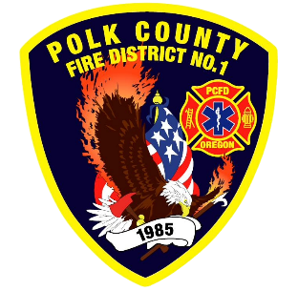
Training and Operations Report
Deputy Chief Training/Operations Neal Olson
December 2025

November Events
Training, Public Education Events, Special Events
- 11/1 WOU Football Standby
- 11/5 Officer and P1FFA Meetings
- 11/6 Salem Fire Accreditation Review
- 11/10 Drakes Crossing Accreditation Review
- 11/10 Board of Directors Meeting
- 11/11 Veteran’s Day Holiday - Office Closed
- 11/12 Drill - Firefighter Skills and FIT Testing
- 11/15 WOU Football Standby
- 11/19 DPSST Fire Policy Committee
- 11/19 Drill - Firefighter Skills and FIT Testing
- 11/24 EMS Drill
- 11/25 Dallas Fire Accreditation Review
- 11/27 Thanksgiving Day Holiday - Office Closed
- 11/28 Holiday - Office Closed

Upcoming Events
- 12/3 Officer and P1FFA Meetings
- 12/4 Polk County Fire Operations Meeting at Dallas Fire
- 12/5 Peer Support Program Meeting
- 12/10 Drill - Firefighter Skills Night
- 12/11 Board of Directors Meeting
- 12/17 Fire District Holiday Party
- 12/24 No Drill - Christmas Eve
- 12/25 Christmas Holiday - Office Closed
- 12/26 Christmas Holiday - Office Closed
- 12/31 No Drill - New Years Eve
Informational Items
- 262 Incidents last month.
- 427 Hours of Training and Continuing Education last month.
- 6 Certification(s) received last month
  - Xander Bailey - Wildland Firefighter Type 2
  - Hailey Solano - HazMat Awareness, Operations and Firefighter I
  - Adam Chinnock - Fire Officer 2
  - Brady Walters - Fire Officer 2
- Ladder 91 is currently being evaluated for equipment needs and relocation of items for more effective operations.
- Rescue 91 is being evaluated and equipped with equipment as we deem necessary.
- Training is working on an acquired structure for Live Fire training in late January or early February.

Training Calendar
