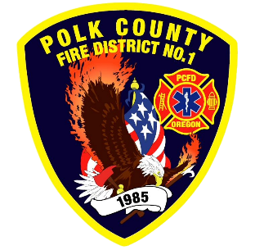
EMS and Logistic Report
Division Chief of EMS/Logistics Frank Ehrmantraut
May 2026

April Highlights
- State of Healthcare – The District was invited to attend a presentation from Salem Health on the current state of their hospital system including future plans for our communities.
- Pediatric Advanced Life Support – The District was able to host two PALS classes for our members who are required to have this certification as a condition of employment. The ability to host the class in-house has significantly reduced costs and improved compliance with this requirement.
- OFCA EMS Section – The EMS section, a division of the Oregon Fire Chiefs Association, met to discuss various possibilities for providing value to our members. This group is also a resource for best practices and protocol development.
- Area Trauma Advisory Board – This quarterly meeting serves as an opportunity for hospital trauma services, trauma surgeons, physician advisors, and EMS chiefs to discuss the trauma system in our region. There has been a strong focus on identifying EMS under- and over- triage and ensuring that finite resources are allocated appropriately.
- Chemeketa Open House – The District participated in an Open House at the Brooks Campus to highlight the various agencies and programs related to their fire and EMS educational offerings.
- Mobile Health Services Workgroup – Willamette Health Council, the non-profit that oversees local Medicaid providers, reached out to the District to discuss a potential grant partnership regarding community paramedicine. We have had several meetings to review and agree on the potential details.
- Process Improvement Workgroup – Chief Ehrmantraut is on a state workgroup to create a process improvement toolkit for EMS leaders to use who may be new to quality management.
- Prehospital Emergency Airway Course – Train the Trainer – A few members of the District are now qualified to teach PEAC within our region. This course is required for Washington Paramedics.
- EMS Collaboration – The District and OHSU School of Nursing participated in a day long simulation of 911 calls, transported by EMS trainees, to be delivered to a faux emergency department managed by nursing students.
- Narcan Training – The District has partnered with the County to provide Narcan training to interested citizens. We recently had the opportunity to participate in a training event.

Apparatus Updates
- E92 – Auxiliary pump evaluated for failure to start. Loose wiring was the culprit
- E93 – Wiper blades replaced, power strip replaced
- M474 – Oil leak that was repaired.
- M477 – Oil leak that was repaired. On board medication cooler replaced.
- M480 – Lube, oil and filter. On board medication cooler replaced.
- L92 – Annual inspection completed and several small things fixed/replaced, e.g. strobe and marker lights
- Medic Units – New charging stations installed to improve battery life and decrease charging time.

