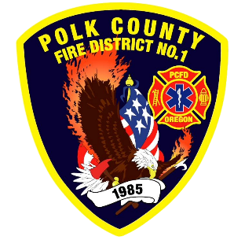
Fire Prevention Report
Division Chief Fire Marshal Troy Crafton
April 2026

March Events
Plan Review, Inspections, Training, Incident Response
- TMS Forensics Science Class
- Kid Central Pub Ed
- Ash Creek Elementary Reading to 3rd and 4th Grade
- Fire Extinguisher Training
- Rogers Road Burn to Learn
- Kid Central License Inspection
- Family Building Blocks License Inspection
- Riddle Road Apartments Final 4 Buildings
- 5 - WOU Fire Alarm Finals
- 8 - Food Truck Inspections
- 3 - Complaint Inspections
- 3 - Driveway inspections
- 8 - Business Inspection
- 7 - Plan Review Projects
- 2 - Smoke Alarm Installs
- Flow MSP set up and Pre-Plans
- Risk Reduction Grant for District Addressing / Preplanning / Wildfire Mitigation
- 7 Hours Fire Marshal Service IGA Dallas Fire Department
- 0 Hours Fire Marshal Service IGA Polk County Building Department
- 2 Incident With .75 Hours of Response
Upcoming Events
- Pre-Application Meeting - 635 Walnut
- Education Webinar Series: Improving Relationships
- Pre-26-02 16th St Subdivision
- Safety Committee Meeting
- Officer Meeting
- Monmouth City Project Meeting
- Independence City Project Meeting
- Monmouth Building Meeting Every Thursday
- Dallas DRT Meeting Every Thursday
- MPFIT Meeting
- OLST Meeting
- Youth with Fire Workshop
- Fire Official Quarterly Meeting
Activities
- Willamette Valley Wildfire Coalition
- Pacific Power 2026 Oregon Wildfire Webinar
- 16th Street Sub Check-In
- Youth with Fire Workshop
- Safety Committee Meeting
- Officer Meeting
- Monmouth City Project Meeting
- Independence City Project Meeting
- Monmouth Building Meeting Every Thursday
- Dallas DRT Meeting Every Thursday

