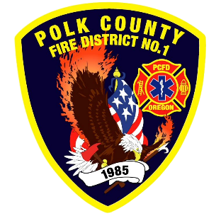
EMS and Logistic Report
Division Chief of EMS/Logistics Frank Ehrmantraut
March 2026

January Highlights
- Paramedic Academy – Firefighters Hoem, Johnson, Li and Taylor are near the end of their paramedic schooling. This was a two-day academy to set expectations, evaluate skills, and train on procedures as the work into a new role at our agency.
- Polk ASA – There have been two meetings with Polk County and other ASA members to discuss the feasibility and tactics of a closest unit response for specific call types. No final decisions have been made.
- Oregon Health Authority EMS Advisory Committee – This group, to which Chief Ehrmantraut is appointed, meets quarterly to make recommendations regarding EMS providers and ambulance services.
- Oregon Health Authority EMS Advisory Board – This group, to which Chief Ehrmantraut is appointed, oversees several committees related to EMS delivery, compiles and prioritizes those recommendations, and gives direction to the Oregon Health Authority’s EMS Program on future activities.
- Pro Tactile Play – The relationship Chief Crafton has cultivated with the protactile community resulted in several members of our agency being invited to a protactile play. Several members attended the play with their sense of sight and hearing dulled to be able to experience it from the perspective of a person who is deaf and blind.
- Oregon Medical Board EMS Advisory Committee – This group, to which Chief Ehrmantraut is appointed, review recommendations and advises the OMB on changes to EMS provider scope of practice.
- Blood Drive – The District regularly hosts the American Red Cross for a blood drive. Our site is one of the regions highest and most consistent collection sites.
Apparatus Updates
- E461 - Officer’s seatbelt replaced.
- E469 – Annual service.
- E473 – Grinder repaired. Check engine light evaluated. DEF topped off.
- R485 – Outfitting is at 95% completion, ready for service while waiting for a few small things.

