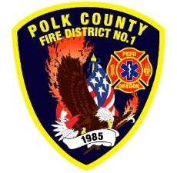Fire Prevention Report

**For Board Meeting, August 13, 2024**

**By Division Chief Fire Marshal Troy Crafton**

**July’s Events** (Plan Review, Inspections, Training, Incident Response)

* Pancake Feed, Parade July 4th
* Cultivating Understanding Through Meaningful Conversations Class July 25th
* 2024 Educational Webinar Series- Wildfire Prevention July 30th
* WOU Student Success Hydro
* Monmouth City Hall Inspection
* Parallel 45 Final Inspection
* Steam Line at WOU Inspection
* Heron Pointe Inspection
* Strategic Planning Meeting
* 2 Knox Box Install
* 10 Plan Reviews
* 2 Smoke Alarm Installs
* Active 911 Maintenance
* Risk Reduction Grant for District Addressing / Preplanning
* Plan Review IGA Planning With Monmouth And Independence Building Departments
* 3 Hours Fire Marshal Service IGA Dallas Fire Department
* 5 Incidents With 2.75 Hours Of Response

**Upcoming Events** (Plan Review, Inspections, Training)

* Officer Meeting August 7th
* Monmouth City Project Meeting August 8th
* Community Fiesta Independence Meeting August 15th
* MPFIT Meeting August 20th
* Strategic Plan Action Planning July 30th
* PUB ED at Family Building Blocks August 22nd
* Adding Mid-Block Crossings Independence August 26th
* Dallas DRT Meeting Every Thursday

**Activities** (Meetings)

* Officer Meeting July 3rd
* Monmouth City Project Meeting July 11th
* OLST Meeting July 23rd
* Monmouth Public Works Planning July 26th
* Strategic Plan Action Planning July 30th
* Dallas DRT Meeting Every Thursday