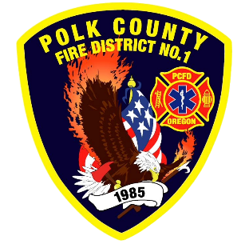
Training and Operations Report
Deputy Chief Training/Operations Neal Olson
March 2026
February Events
Training, Public Education Events, Special Events
- 2/4 Officer Meeting and P1FFA
- 2/4 Recruit Academy Orientation
- 2/5 Capitol Fire Operations Meeting
- 2/10 Mid-Willamette Fire Instructors Meeting
- 2/11 Drill - Hose Deployment
- 2/12 Board of Directors Meeting
- 2/16 President’s Day Holiday (Office Closed)
- 2/18 Drill - Engine Company Evolutions
- 2/21 Winter Fire School
- 2/22 Winter Fire School
- 2/25 Fire Policy Committee - DPSST
- 2/25 Drill - Engine Company Evolutions and Ventilation
- 2/27 Capt. Rusher Retirement Reception 1600-1800, Sta. 90
- 2/28 2026 Annual Awards Banquet

Upcoming Events
- 3/4 Officer Meeting and P1FFA
- 3/4 Recruit Academy Fire Extinguishers
- 3/8 Seattle Stairclimb
- 3/9 CHS Career Fair
- 3/10 Fire Service Meeting WVCC
- 3/10 Mid-Willamette Fire Instructors Meeting
- 3/11 Drill - ICS Overview, Vehicle Maintenance, Academy Ropes and Knots
- 3/12 Board of Directors Meeting
- 3/13 S-215 Fire Operations in the Urban Interface (Two day class)
- 3/13 HazMat Operations Class at Falls City Fire 3/13, 14, 21
- 3/14 Recruit Academy - Hose
- 3/15 Live Fire Training on Rogers Rd.
- 3/18 Drill - Communications and Radio Training, Academy Ground Ladders
- 3/19 Region 2 MCI Drill
- 3/25 Drill - HazMat Refresher

Informational Items
- 312 Incidents last month.
- 830 Hours of Training and Continuing Education last month.
- 2 Certification(s) received last month
  - Max Patel: Wildland Firefighter Type 2
  - Neal Olson: Fire and Life Safety Educator
- 2026 Engineer Academy begins this month.

Training Calendar
