

August 2025 Report for the month of July 2025

Deputy Chief – Neal Olson

**This Month’s Events** (i.e. Training, Public Education Events, Special Events)

* 7/2 Recruit Graduation, Swearing in of recently promoted personnel
* 7/3 Hometown Fireworks
* 7/4 Pancake Feed and July 4th Festivities
* 7/9 Drill - Firefighter Survival and Breathing Techniques, Engineer Academy
* 7/9 Task Force 25 deployed to Elk Fire in Bonanza, redeployed to Highland Fire in Prineville, TFL Austin Champ, TFL(T) Lukas Martin, B81 with Olson and Andersen, returned 7/15.
* 7/16 Drill - Fire Streams and Team Building (waterball)l, Engineer Academy
* 7/21 EMS Drill
* 7/23 Drill – Forcible Entry, Engineer Academy (DPSST will be providing their Forcible Entry Prop for our personnel to utilize from July 19 through Aug 4, 2025)
* 7/30 Drill - Structural Search, Thermal Imaging Cameras and Engineer Academy

**Upcoming Events** (i.e. Training, Public Education Events, Special Events)

* 8/6 Officer and P1FFA Meetings
* 8/13 Drill: Straight Ladders - Carries and Raises, Engineer Academy
* 8/13 Olson at DPSST for EMD Course, W, Th, F
* 8/14 Board of Directors Meeting
* 8/20 Drill: Extension Ladders - Carries and Raises, Engineer Academy
* 8/25 EMS Drill
* 8/27 Drill: Working from ladders, hoselines and rescues, Engineer Academy

**Informational Items –**

* **358** Incidents last month.
* **645** Hours of Training and Continuing Education last month.
* **12** Certification(s) received last month
  + Elijah King - Firefighter I, Wildland Firefighter Type 2, HazMat Awareness and Operations
  + Max Patel - Hazardous Materials Awareness and Operations
  + Leo Mellein - Pump Operator
  + Tom Dalke - Instructor I
  + Frank Ehrmantraut - Strike Team Leader and Task Force Leader
  + Alex Schilz - NFPA Fire Officer 1
  + Austin Champ - Fire Officer II

Training Calendar

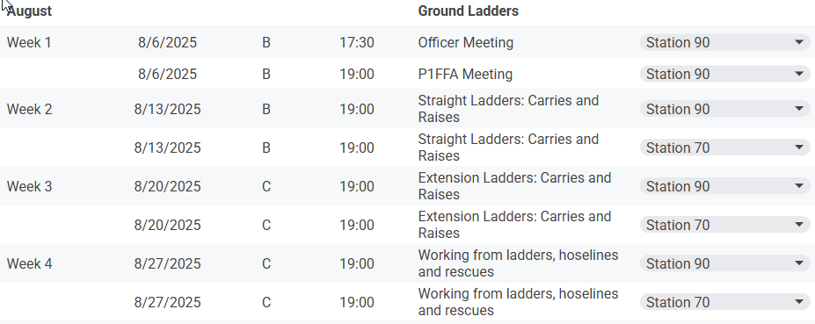

*Respectfully Submitted*

***Neal Olson***