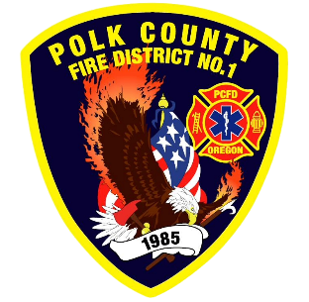
Training and Operations Report
Deputy Chief Training/Operations Neal Olson
July 2026
June Events
Training, Public Education Events, Special Events
- 6/3 Officer and P1FFA Meeting
- 6/5 Metro Area Wildfire School
- 6/5 Central High School Graduation Ceremony Standby
- 6/6 Metro Area Wildfire School
- 6/9 Olson at DPSST for EMD class 6/9, 10
- 6/10 Drill - Conflagration Pre-Season Review, Confined Space and Gas Monitors
- 6/13 WOU Commencement Standby
- 6/13 S-131 Wildland Firefighter Type I in Silverton
- 6/17 Operational Peer Support Symposium at DPSST
- 6/17 Drill - Structural Search Tactics
- 6/19 Juneteenth Holiday - Office Closed
- 6/14 Drill - Multi-Company Evolutions New Ropes Bags and system
- 6/27 Live Fire Training at Adair Rural with Mobile Fire Training Unit

Upcoming Events
- 7/1 Officer and P1FFA Meeting
- 7/2 Meeting with Shift Captain’s
- 7/3 Independence Days with Hometown Fireworks
- 7/4 Independence Day: Pancake Breakfast, Parade and Fireworks
- 7/7 Safety Committee Meeting
- 7/8 Drill - GRAB LIVES
- 7/9 Board of Directors Meeting
- 7/15 Drill - Ropes and Haul Systems
- 7/17 Skyler Li and Amaryn Camero Wedding
- 7/22 Drill - Forcible Entry
- 7/27 EMS Drill
- 7/29 Drill - Firefighter Survival / Breathing Techniques

Informational Items
- 319 Incidents last month.
- 1,158 Hours of Training and Continuing Education last month.
  - DPSST Mobile Fire Training Unit was a great experience for the Recruits.
- 3 Certification(s) received last month
  - Adam Chinnock: Live Fire Instructor In-Charge
  - JJ Chinnock: Firefighter I, HazMat Awareness and Operations
  - Nick Wooldridge: Fire Officer I

Training Calendar
