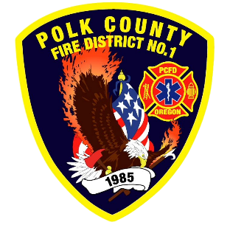
EMS and Logistic Report
Division Chief of EMS/Logistics Frank Ehrmantraut
February 2026

January Highlights
- Regional MCI Exercise Planning – The District is participating in the planning for a Region 2 MCI and Surge Exercise involving emergency management, EMS, hospitals and public health.
- OFCA Career Roundtables – This was a great experience to learn from our peers in the Oregon Fire Service.
- WOU Intern – Victoria Zimmerman (former office assistant) is completing her practicum at the Fire District to earn her undergraduate degree in Gerontology. She is currently surveying senior citizens who have recently utilized EMS services.
- OFCA EMS Section – This group provides the District with a wealth of knowledge, resources and the opportunity to network with peers.
- EMS Committee – This internal group of EMS providers meets regularly to make recommendations on EMS related equipment, protocols and guidelines. They also serve as the District’s quality management committee.
- Polk County ASA Committee Meeting – This quarterly meeting was hosted by Polk County Emergency Management to discuss and make decisions on issues pertaining to ASA providers and the rules that they must follow.
- Pedee Women’s Club – The District met with the Women’s Club to keep them informed about the work at the Pedee Station including the hopeful addition of a generator that would power our station and their building in the event of an emergency.
Apparatus Updates
- All of our fire pumps passed testing!
- M477 -Rear doors were fixed. The turn signal was fixed.
- M474 - Compartment door strut was replaced.
- E93 – Running lights and windshield wipers were replaced.
- D464 - Brake light replaced.
- E469 - Batteries were replaced.
- M480 - Stretcher trolley was cleaned and evaluated.
- B81 - The upfit was completed.

