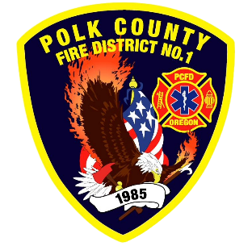
Training and Operations Report
Deputy Chief Training/Operations Neal Olson
April 2026
March Events
Training, Public Education Events, Special Events
- 3/4 Officer Meeting and P1FFA
- 3/4 Recruit Academy Fire Extinguishers
- 3/8 Seattle Stairclimb
- 3/9 CHS Career Fair
- 3/10 Fire Service Meeting WVCC
- 3/10 Mid-Willamette Fire Instructors Meeting
- 3/11 Drill - ICS Overview, Vehicle Maintenance, Academy Ropes and Knots
- 3/12 Board of Directors Meeting
- 3/13 S-215 Fire Operations in the Urban Interface (Two day class)
- 3/13 HazMat Operations Class at Falls City Fire 3/13, 14, 21
- 3/14 Recruit Academy - Hose
- 3/15 Live Fire Training on Rogers Rd.
- 3/18 Drill - Communications and Radio Training, Academy Ground Ladders
- 3/19 Region 2 MCI Drill
- 3/25 Drill - HazMat Refresher

Upcoming Events
- 4/1 Officer and P1FFA Meeting, Academy Hose Skills
- 4/3 Olson teaching CPR Science at DPSST
- 4/7 Strategic Plan and Safety Committee Meeting
- 4/8 Captain Assessment Center
- 4/8 Drill - Extended Attack Lines, Academy Hose
- 4/9 Board of Directors Meeting
- 4/15 Drill - Utilities, Water Supply, Academy Loss Control
- 4/22 Olson on Wildland Certification Task Force at DPSST
- 4/22 Drill - 3rd Floor Standpipes, Academy Building Construction
- 4/23 Keizer Fire Accreditation Review
- 4/28 Polk County Mobilization Resource Meeting
- 4/29 Drill - 75’ Ladder Climb, Ground Ladders, Academy Fire Dynamics
- 4/29 Olson at S-330 Task Force Leader Class 4/29-5/1

Informational Items
- 325 Incidents last month.
- 1,686 Hours of Training and Continuing Education last month.
  - Personnel attended several multi-day classes; ICS-400, S-215, IMT3, Fire Investigator and HazMat Operations
- 1 Certification(s) received last month
  - Alex Schilz - Mobile Water Supply Apparatus Operator

Training Calendar
