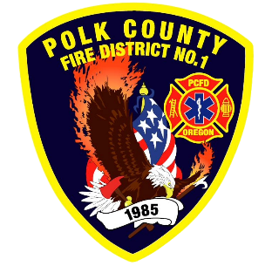
EMS and Logistic Report
Division Chief of EMS/Logistics Frank Ehrmantraut
April 2026

February Highlights
- Polk County ASA Committee – Conversations have been continuing on closest unit response with a tentative agreement to try a closest medic unit response on CPRs, CRASH1, CRASH2, and TRAP.
- Youth Conference – B Shift and Chief Ehrmantraut presented to high school juniors from around the county on the role of a paramedic and how someone might begin their journey to become one.
- Region 2 MCI Exercise – The partners from the Region 2 Healthcare Coalition (hospitals, EMS, public health, and emergency management) participated in a regionwide virtual mass casualty incident to test the new MCI plan and leadership functions. Lt Emerling and Engineer Wells attended this training as part of their leadership development.
- OFCA EMS Section Roundtable – EMS leaders from across the state met for this one-day event where we had the opportunity to network and share our solutions to common struggles.
- Quality Assurance/Performance Improvement Workgroup – The District is offering expertise to this state workgroup to create a performance improvement handbook that can be used by agencies that may need assistance in creating their own programs.
Apparatus Updates
- E93 - Air leak fixed, TIC wiring fixed, Officer window seal deferred
- E92 - Kussmaul replaced
- M477 - Rear panel tightened
- B91 - Annual Inspection and LOF
- M474 - Rear doors adjusted

