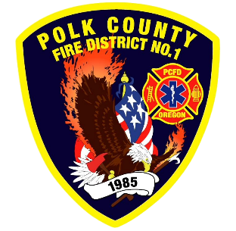
Fire Prevention Report
Division Chief Fire Marshal Troy Crafton
June 2026

May Events
Plan Review, Inspections, Training, Incident Response
- Touch-A-Truck
- Fire Safety at TMS
- Forensic Science at TMS
- Deaf Blind Q and A
- 3 - Food Truck Inspections
- 2 - Complaint Inspections
- 2 - Driveway inspections
- 16 - Business Inspection
- 12 - Plan Review Projects
- 2 - Smoke Alarm Installs
- Flow MSP set up and Pre-Plans
- Risk Reduction Grant for District Addressing / Preplanning / Wildfire Mitigation
- 9 Hours Fire Marshal Service IGA Dallas Fire Department
- 0 Hours Fire Marshal Service IGA Polk County Building Department
- 2 Incident With .75 Hours of Response
Upcoming Events
- OSHA Inspection
- Last Day of School PUB ED
- Willamette Valley Wildfire Coalition
- Youth with Fire Workshop
- IAAI Meeting
- MBA Meeting
- MICC Meeting
- Safety Committee Meeting
- Officer Meeting
- Monmouth City Project Meeting
- Independence City Project Meeting
- Monmouth Building Meeting Every Thursday
- Dallas DRT Meeting Every Thursday
- MPFIT Meeting
- OLST Meeting
- Youth with Fire Workshop
Activities
- Youth Fire intervention
- Pre-Application - 760 S. Main Street
- Pre-Application Meeting - 389 C Street
- Safety Committee Meeting
- Officer Meeting
- Monmouth City Project Meeting
- Independence City Project Meeting
- Monmouth Building Meeting Every Thursday
- Dallas DRT Meeting Every Thursday
- IAAI Meeting
- MBA Meeting

